New Software House Interface
Specification for Software Suppliers
02 September 2008

Version 1.8

Table of Contents
1 Document History 3
2 Scope of document 3
3 Overview of Strategy 4
3.1 Minimise Change for Software Houses 4
3.2 Minimise Implementation Risk for CNS Customers and Stakeholders 4
4 Overview of Current Architecture 5
5 Overview of New Architecture 6
6 New Software House Interface 7
6.1 Web Service Security 7
6.2 Test Services Available 7
6.2.1 Simple Web Service 7
6.2.2 CHIEF EDI Service 9
6.2.3 Mailbox Service 13
6.3 Change to Length of Maritime UCN 16
6.4 FTP and SMTP 16
7 Development of New Software House Interface 16
7.1 Overview 16
7.2 Supply of Test Installations 17
8 Strategy for Implementation 17
8.1 CHIEF Reports 17
8.2 CHIEF Messaging and Mailboxes 17
8.3 Other Infrastructure Components 18
9 CNS Test Strategy 18
10 Project timelines 18
11 Contact 18

Document History
Version and date | Author | Changes
V 1.0-final  31 March 2008 | Matthew Bradley | Original version
V 1.1-final  15 May 2008 | Matthew Bradley | Changes to error messages for inventory pre-check and communications with CHIEFError: Reference source not found  Revision to timetable in section Error: Reference source not found.  Other minor revisions.
V1.2  30th May 2008 | Keith Harris | Additional detail added to Web Service.
V1.3  18 June 2008 | Matthew Bradley | Updated project timescales.  Renamed BEA Aqualogic Service Bus as Oracle Service Bus to reflect new Oracle branding.
1.4  20 June 2008 | Matthew Bradley | Corrections from Marketing and Communications.
1.5  10 July 2008 | Alex Mountney | Separation of CHIEF EDI and Mailbox services.
1.6  29 August 2009 | Matthew Bradley | Updated project timescales.
1.7  29 August 2009 | Matthew Bradley | Change to test IP address.
1.8  02 September 2009 | Alex Mountney | Change to URL for test system  Completion of missing IRC failure codes

Scope of document
This document describes the new software house interface to CNS for CHIEF messaging and includes the following:
- CNS overall strategy for the interface.
- Architecture of the current solution.
- Architecture of the new solution.
- Description of the new interface.
- Strategy for development of the new interface in partnership with software houses.
- Strategy for roll out of the new interface in partnership with software houses.
The following areas are out of scope of this document:
- Air Courier Manifest interface for software houses. This will be the subject of separate communication with those software houses who support this customer base.
- New CNS Inventory, known as CNS Compass. Development and cutover to the new software house interface is part of the roadmap to replacement of the current CNS solution. CNS will contact software houses at a later date to brief them on the new inventory. Software houses should note that CNS will not be supporting structured messages from the inventory in the first release of the new inventory product.

Overview of Strategy
The aims of CNS’ strategy for new software house interface are to:
- Minimise change for customers and software houses.
- Minimise implementation risk for CNS customers and stakeholders.

Minimise Change for Software Houses
CNS has reviewed the options for its new software house interface and has concluded that an approach which minimises change for software houses has the following benefits:
- Minimised development and testing timescales.
- Improved quality of overall solution.
CNS has identified an opportunity to leverage the software interface that Maritime Cargo Processing (MCP) provides to its Destin8 product. Following detailed discussions with MCP, and with the kind agreement of MCP, CNS will provide an interface based closely on the Destin8 interface for:
- CHIEF EDI.
- CHIEF PRT.
In the future CNS plans to provide FTP and SMTP to customers who require it.

Minimise Implementation Risk for CNS Customers and Stakeholders
CNS will minimise the implementation risk for its new infrastructure in three ways:
- CNS will implement changes to the infrastructure in advance of any changes to the inventory application. This will allow the CNS Helpdesk, support, development and management teams to focus on ensuring a smooth infrastructure roll out.
- All functional components of the new infrastructure, with the exception of CHIEF reports, can be moved to the new infrastructure on a customer by customer basis.
- Each functional component of the new infrastructure, including the software house interface, can be rolled out separately.

Overview of Current Architecture
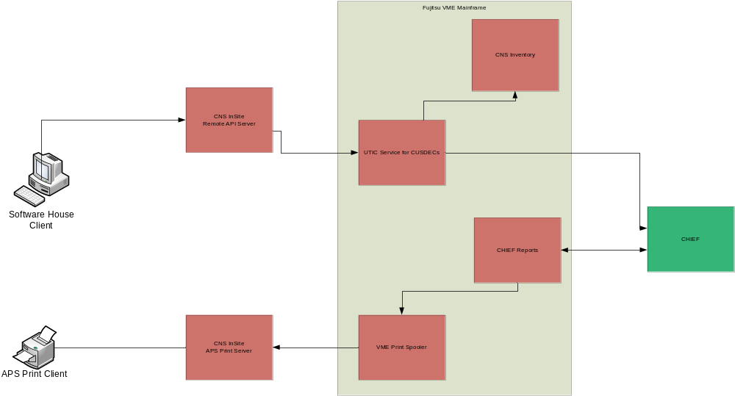
The architecture that supports the current software house interface is based on the following components:
- Fujitsu VME mainframe, this provides:
  - Terminal access.
  - Print spooling.
  - Communications with CHIEF.
  - Translation of CHIEF reports to plain text.
  - Application functionality for inventory pre-check and air courier manifest.
- CNS InSite Remote API Server provides a software API to terminal sessions for Windows based clients.
- CNS InSite APS Print Server delivers mainframe prints to customer printers.
This architecture is based on legacy mainframe technology which presents challenges for both CNS and software houses to support and maintain.

Overview of New Architecture
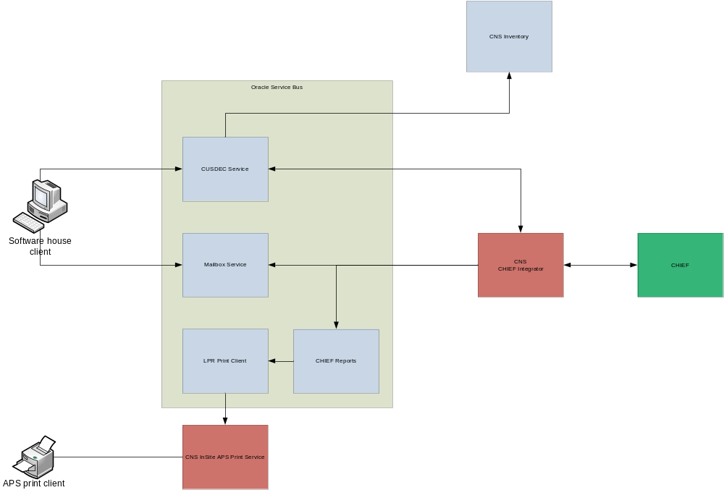

The new architecture is based on the following components:
- Oracle Service Bus which provides an integration backbone for current and future messages and services.
- CUSDEC service which provides an http SOAP interface for transmission of CHIEF CUSDEC messages.
- Mailbox service which provides an http SOAP interface for retrieval of EDIFACT CUSRES report messages.
- CNS CHIEF Integrator which provides communications links between Oracle Service Bus and CHIEF. This component has been in production since October 2007 supporting CNS’ largest customers.
- CHIEF Reports which translates from CHIEF CUSRES reports to plain text where required.
- LPR print client which delivers prints to the CNS InSite APS print service.
- CNS Inventory which provides application functionality for inventory pre-check.

New Software House Interface
The new software house interface will be known as CHIEF Customer Messaging Interface (CCMI). As described above, CNS will be adopting the MCP software house interface for CHIEF CUSDEC messaging and CHIEF reports.

Web Service Security
CNS will implement both transport level and application level security:
- Transport encryption will be provided by HTTPS.
- Client connections must come from a pre-agreed fixed IP address.
- Authentication is provided within the HTTP interaction using username and password.
- CNS will validate that the client is authorised to use the CHIEF agent role specified in the UNB or CompanyCode.

Test Services Available
- Simple Web Service
  - URI : https://195.171.138.110/ws/SimpleWeb
  - WSDL : https://195.171.138.110/ws/SimpleWeb?WSDL
- CHIEF EDI Web Service
  - URI : https://195.171.138.110/ws/CCMI/ChiefEDI
  - WSDL : https://195.171.138.110/ws/CCMI/ChiefEDI?WSDL
- Mailbox Web Service
  - URI : https://195.171.138.110/ws/Mailbox/MailBoxPortImpl
  - WSDL : https://195.171.138.110/ws/Mailbox/MailBoxPortImpl?WSDL

Notes:
- The two CNS services, “CHIEF EDI” and “Mailbox” are equivalent to the single MCP service “CHIEF EDI”.

Simple Web Service

Service Summary
This service has been implemented as a test service to check connectivity and authentication. This service will be the same as the MCP SimpleWeb Service so will have the following two methods available:
- toLower (String)
- toUpper (String)

toLower Method
The toLower method will return the input in lower case.

Request:
<soapenv:Envelope xmlns:xsi="http://www.w3.org/2001/XMLSchema-instance" xmlns:xsd="http://www.w3.org/2001/XMLSchema" xmlns:soapenv="http://schemas.xmlsoap.org/soap/envelope/" xmlns:sim="http://www.destin8.co.uk/SimpleWeb">
<soapenv:Header/>
<soapenv:Body>
<sim:toLower soapenv:encodingStyle="http://schemas.xmlsoap.org/soap/encoding/">
<string xsi:type="xsd:string">AbcD</string>
</sim:toLower>
</soapenv:Body>
</soapenv:Envelope>

Response:
<soapenv:Envelope xmlns:soapenv="http://schemas.xmlsoap.org/soap/envelope/">
<soapenv:Header xmlns:xsi="http://www.w3.org/2001/XMLSchema-instance" xmlns:xsd="http://www.w3.org/2001/XMLSchema" xmlns:sim="http://www.destin8.co.uk/SimpleWeb"/>
<soapenv:Body xmlns:xsi="http://www.w3.org/2001/XMLSchema-instance" xmlns:xsd="http://www.w3.org/2001/XMLSchema" xmlns:sim="http://www.destin8.co.uk/SimpleWeb">
<sim:toLowerResponse>
<result><string xsi:type="xsd:string">abcd</result>
</sim:toLowerResponse>
</soapenv:Body>
</soapenv:Envelope>

Notes:
- An Input string is mandatory.

toUpper Method
The toUpper method will return the input in upper case.

Request:
<soapenv:Envelope xmlns:xsi="http://www.w3.org/2001/XMLSchema-instance" xmlns:xsd="http://www.w3.org/2001/XMLSchema" xmlns:soapenv="http://schemas.xmlsoap.org/soap/envelope/" xmlns:sim="http://www.destin8.co.uk/SimpleWeb">
<soapenv:Header/>
<soapenv:Body>
<sim:toUpper soapenv:encodingStyle="http://schemas.xmlsoap.org/soap/encoding/">
<string xsi:type="xsd:string">AbCd</string>
</sim:toUpper>
</soapenv:Body>
</soapenv:Envelope>

Response:
<soapenv:Envelope xmlns:soapenv="http://schemas.xmlsoap.org/soap/envelope/">
<soapenv:Header xmlns:xsi="http://www.w3.org/2001/XMLSchema-instance" xmlns:xsd="http://www.w3.org/2001/XMLSchema" xmlns:sim="http://www.destin8.co.uk/SimpleWeb"/>
<soapenv:Body xmlns:xsi="http://www.w3.org/2001/XMLSchema-instance" xmlns:xsd="http://www.w3.org/2001/XMLSchema" xmlns:sim="http://www.destin8.co.uk/SimpleWeb">
<sim:toUpperResponse>
<result xsi:type="xsd:string"> ABCD</result>
</sim:toUpperResponse>
</soapenv:Body>
</soapenv:Envelope>

Notes:
- An Input string is mandatory.

CHIEF EDI Service

Service Summary
The CHIEF EDI message service will correspond to the MCP CHIEF EDI service. So will have the following method:
- processEDIMessage(EDI, CompanyCode, Operational).

processEDIMessage Method
This method is for clients to submit CUSDECs to CNS for Cusdec Pre-check and then subsequently to CHIEF and to then receive the relevant responses as per the current system. (see Inventory pre-check section 6.2.2.5)
Request:
<soapenv:Envelope xmlns:xsi="http://www.w3.org/2001/XMLSchema-instance" xmlns:xsd="http://www.w3.org/2001/XMLSchema" xmlns:soapenv="http://schemas.xmlsoap.org/soap/envelope/" xmlns:chi="http://www.destin8.co.uk/Chief">
<soapenv:Header/>
<soapenv:Body>
<chi:processEDIMessage soapenv:encodingStyle="http://schemas.xmlsoap.org/soap/encoding/">
<EDI xsi:type="xsd:string"> UNH+00000000146374+CUSDEC:D:04A:UN:109741+W02747J4JVG'BGM+ESD::109:GBP++9'CST++EXY+3'LOC+14+GBLSA::109'LOC+36+US'LOC+35+GB'DTM+148:200805200000:203'DTM+189:20080521:102'RFF+ABO:8GB222421710-05-MU041810204:10'TDT+13++4+++++::::US'TDT+1++3'NAD+CZ+GB283217657000'NAD+CN+++COMPANY+ADDRESS+TOWN++ZIP+US'NAD+DT+GB222421710019'UNS+D'DMS+1ZW027470450523034'CST++1000009+87089997'FTX+ACB++30200+SIMPLIFIED EXPORTATION'MEA+AAR++KGM:28.0'PAC+1++PC'PCI++W02747J4JVG'MOA+123:1938.44'RFF+AAQ:UNKNOWN'RFF+ZZZ'DOC+998:::380+566830:::::Z'DOC+998:::CLE+20080521/A68914C/555:::::Y'UNS+S'CNT+11:1' UNT+29+00000000146374'</EDI>
<CompanyCode xsi:type="xsd:string">ABC</CompanyCode>
<Operational xsi:type="xsd:boolean">true</Operational>
</chi:processEDIMessage>
</soapenv:Body>
</soapenv:Envelope>

Response:
<soapenv:Envelope xmlns:xsi="http://www.w3.org/2001/XMLSchema-instance" xmlns:xsd="http://www.w3.org/2001/XMLSchema" xmlns:soapenv="http://schemas.xmlsoap.org/soap/envelope/" xmlns:chi="http://www.destin8.co.uk/Chief">
<soapenv:Header/>
<soapenv:Body>
<chi:processEDIMessageResponse soapenv:encodingStyle="http://schemas.xmlsoap.org/soap/encoding/">
<Response xsi:type="xsd:string"> UNH+01234567890123+CUSRES:D:04A:UN:109123+1Q1234YHFSC'
BGM+ESD::109:GBP++27'
RFF+ABO:5HJ012345678-01-NM012345678:12'
ERP+:3:1+CST:29:5'
ERC+10::109'
FTX+AAO+++CNS007 Vessel has not arrived'
DOC+960+1S5F12345678901234'
UNT+8+01234567890123'</Response>
</chi:processEDIMessageResponse>
</soapenv:Body>
</soapenv:Envelope>

Notes:
- EDI is mandatory.
- CompanyCode (CHIEF Role) is optional see ‘Use of Envelopes’ below for conditions.
- Operational is optional see ‘Use of Envelopes’ below for conditions.

Use of envelopes
The EDIFACT CUSDEC may be supplied with or without a UNB envelope:
- If a UNB envelope is supplied, the CompanyCode and operational parameters of the web service will be ignored and taken from the UNB envelope.
- If a UNB envelope is not supplied, the CHIEF role and training/operational indicators will be derived from the CompanyCode and operational parameters of the web service.
- Response messages will be enveloped in the same way as the request:
  - If the CUSDEC has a UNB envelope, the response will have a UNB envelope.
  - If the CUSDEC does not have a UNB envelope, the response will not have a UNB envelope.

The UNB envelope follows the standard layout:
UNB+UNOA:2+CNSAAA::YYYYYY+CNSCHIEFEDI+080327:0002+ZZZZZZZZ++CHIEFLIVE
A training mode entry must include the test indicator:
UNB+UNOA:2+CNSAAA::YYYYYY+CNSCHIEFEDI+080327:0002+ZZZZZZZZ++CHIEFLIVE+++1
AAA | CHIEF role
YYYYYYY | address for reverse routing
ZZZZZZZ | interchange control reference

Delimiters
All messages will use the standard UNOA +,’ and : delimiters. Note that these delimiters are different from the MCP delimiters.

Inventory Pre-Check
The CNS Helpdesk will configure inventory pre-check for maritime customers. If the inventory pre-check fails, the CHIEF CUSDEC message service will respond with an EDIFACT CUSRES rejection, as defined in CHIEF DES 238 v 1.7.

UNH+<SYS-MRN>+CUSRES:D:04A:UN:109<HMRC-ASG-CODE>+<SYS-CAR>'
BGM+<MESSAGE-CODE>::109:27
RFF+ABO:<DECLN-UCR>:<DECLN-PART-NO>'
ERP+:<ELEMENT-NO>:<COMPONENT-NO>+<SEGMENT-TAG:<SEGMENT-NO>:5'
ERC+10::109'
FTX+AAO+++<ERROR-TXT>'
DOC+960+<TDR-OWN-REF-ENT>'
UNT+<SEG-CNT>+<SYS-MRN>'

The following optional fields will be copied from the CUSDEC if they have been supplied:
- SYS-CAR - Optional field.
- DECLN-UCR - Mandatory field within optional segment.
- DECLN-PART-NO - Optional field within optional segment.
- TDR-OWN-REF-ENT - Optional field.
The following is an example of a CUSRES rejection:
UNH+01234567890123+CUSRES:D:04A:UN:109123+1Q1234YHFSC'
BGM+ESD::109:GBP++27'
RFF+ABO:5HJ012345678-01-NM012345678:12'
ERP+:3:1+CST:29:5'
ERC+10::109'
FTX+AAO+++CNS007 Vessel has not arrived'
DOC+960+1S5F12345678901234'
UNT+8+01234567890123'

Inventory pre-check will populate the ERP and FTX segments to reflect the field that is in error. If the error does not relate to an individual field, the ERP segment will be populated with values of 0.

The possible errors are as follows:

IRC | ERROR-TXT
001 | NO MATCHING INVENTORY RECORD
002 | CONSIGNMENT SPLIT
003 | NOT YOUR CONSIGNMENT
004 | ENTRY ALREADY MADE
005 | NUMBER OF PACKAGES INCORRECT
006 | VESSEL HAS ARRIVED
007 | VESSEL HAS NOT ARRIVED
009 | MANIFEST IS NOT COMPLETE
010 | CONSIGNMENT HAS BEEN CLEARED
011 | CONSIGNMENT IS PART OF AN AMALGAMATION
012 | SHORT LANDED UNIT HAS BEEN FROZEN
013 | NOT LATEST VERSION OF ENTRY
014 | NO AGENT NOMINATED
015 | INVALID / MISSING CLEARING AGENT
016 | INVALID MARKS AND NUMBERS RECORD
017 | REMOVAL REQUEST ALREADY MADE
018 | CONSIGNMENT NOT SPLIT
019 | CONSIGNMENT NOT AMALGAMATED
020 | INVENTORY DATABASE ERROR
021 | INVALID EPU
022 | INVENTORY DATABASE ERROR
023 | INVALID TRANSIT SHED / ERTS
024 | INVALID CONSIGNMENT REFERENCE
025 | CUSDEC NOT REQUIRED FOR EC UNIT
026 | CONFIGURATION NOT FOUND
027 | AGENT NOT AUTHORISED FOR JWQ1 ENTRIES

If inventory pre-check cannot read the EDIFACT CUSDEC, it will return an EDIFACT CONTRL message as described in section 6.2.2.7.

CHIEF Communications Errors
If there is an error communicating with CHIEF, the CHIEF EDI service will return an EDIFACT CONTRL message. Scenarios where this can occur include:
- Communications link to CHIEF is not available.
- CHIEF role is not configured in CHIEF.
- CNS is unable to establish a session with CHIEF.

An example of the EDIFACT CONTRL message is given below:

UNH+1234567891234+CONTRL:1:912:UN+1R1234TGVLO'
UCI+00000000112233+CNSCNS1SERVICE::CN1ABC001+CN1ABC+4'
UCM+00000000112233+CUSDEC:D:04A:UN:109741+4+C1'
FTX+AAI+++Cannot connect to CHIEF - IOException on connect?:Connection refused?: connect'
UNT+5+1234567891234'

The structure of the CONTRL message is defined in document CNS CONTRL message for rejection.

Other Errors
If there are other errors in processing a CUSDEC for CHIEF, the CHIEF EDI service will return an EDIFACT CONTRL message.
The structure of the CONTRL message is defined in document CNS CONTRL message for rejection.

Recovery of Failed CUSRES Responses
In the scenario where a client application disconnects before receiving the response from CHIEF, and subsequently discovers that the entry has been successful in CHIEF, the customer should contact CNS. If CNS has received the message from CHIEF, CNS will make this message available in the customer’s mailbox (see section 6.2.3.2). Software houses should therefore ensure that their software can handle a CUSRES acceptance message in the mailbox.

This is particularly pertinent for supplementary declaration responses where there is no facility available in CHIEF to request a copy of the CUSRES.

Mailbox Service

Service Summary
The Mailbox message service will correspond to the MCP CHIEF PRT service. So will have the following methods:
- getAvailableEdifactPrints(CompanyCode, DeviceCode).
- acknowledgeEdifactPrints(CompanyCode, DeviceCode, BatchID).

getAvailableEdifactPrints Method
This service gives the client the facility to request CHIEF prints in their raw EDI format in addition to or instead of physical prints. Once a BATCH of messages has been returned to the client the client is required to acknowledge receipt otherwise the next time the client requests for available messages the client will receive duplicates plus any additional messages which have been received by CNS since the last poll (client should have an average polling rate of no more than once every 30 seconds).

Request:
<soapenv:Envelope xmlns:xsi="http://www.w3.org/2001/XMLSchema-instance" xmlns:xsd="http://www.w3.org/2001/XMLSchema" xmlns:soapenv="http://schemas.xmlsoap.org/soap/envelope/" xmlns:chi="http://www.destin8.co.uk/Chief">
<soapenv:Header/>
<soapenv:Body>
<chi:getAvailableEdifactPrints soapenv:encodingStyle="http://schemas.xmlsoap.org/soap/encoding/">
<CompanyCode xsi:type="xsd:string">ABC</CompanyCode>
<Device xsi:type="xsd:string"></Device>
</chi:getAvailableEdifactPrints>
</soapenv:Body>
</soapenv:Envelope>

Response:
<soapenv:Envelope xmlns:xsi="http://www.w3.org/2001/XMLSchema-instance" xmlns:xsd="http://www.w3.org/2001/XMLSchema" xmlns:soapenv="http://schemas.xmlsoap.org/soap/envelope/" xmlns:chi="http://www.destin8.co.uk/Chief" xmlns:soapenc="http://schemas.xmlsoap.org/soap/encoding/">
<soapenv:Header/>
<soapenv:Body>
<chi:getAvailableEdifactPrintsResponse soapenv:encodingStyle="http://schemas.xmlsoap.org/soap/encoding/">
<result xsi:type="n1:EDIMessageBatch" xmlns:n1="java:com.mcpplc.destin8.common.vo.chief">
<batch xsi:type="n1:Batch">
<batchID xsi:type="xsd:int">999</batchID>
<messageCount xsi:type="xsd:int">1</messageCount>
<messages xsi:type="n:ArrayOfPrintMessage" soapenc:arrayType="n1:PrintMessage[]"/>
<PrintMessage xsi:type="xsd"n1:PrintMessage[1]">
<Message xsi:type="xsd:string">EDI PRINT DATA</Message>
</PrintMessage>
</messages>
</batch>
<errorNo xsi:type="xsd:int">?</errorNo>
<errorText xsi:type="xsd:string">?</errorText>
</result>
</chi:getAvailableEdifactPrintsResponse>
</soapenv:Body>
</soapenv:Envelope>

Notes:
- The CompanyCode (CHIEF Role) is redundant
- The client will have one or more mailbox names; the mailbox name will be put into the DeviceCode and all mail available in the given mailbox will be returned to the client.

acknowledgeEdifactPrints Method
This service must be called after a batch on messages has been returned with a BatchID by the getAvailableEdifactPrints method. CompanyCode and DeviceCode are not required and will be ignored. BatchID is mandatory.

Request:
<soapenv:Envelope xmlns:xsi="http://www.w3.org/2001/XMLSchema-instance" xmlns:xsd="http://www.w3.org/2001/XMLSchema" xmlns:soapenv="http://schemas.xmlsoap.org/soap/envelope/" xmlns:chi="http://www.destin8.co.uk/Chief">
<soapenv:Header/>
<soapenv:Body>
<chi:acknowledgeEdifactPrints soapenv:encodingStyle="http://schemas.xmlsoap.org/soap/encoding/">
<CompanyCode xsi:type="xsd:string">?</CompanyCode>
<Device xsi:type="xsd:string"></Device>
<BatchID xsi:type="xsd:string">9999</BatchID>
</chi:acknowledgeEdifactPrints>
</soapenv:Body>
</soapenv:Envelope>

Response:
<soapenv:Envelope xmlns:xsi="http://www.w3.org/2001/XMLSchema-instance" xmlns:xsd="http://www.w3.org/2001/XMLSchema" xmlns:soapenv="http://schemas.xmlsoap.org/soap/envelope/" xmlns:chi="http://www.destin8.co.uk/Chief">
<soapenv:Header/>
<soapenv:Body>
<chi:acknowledgeEdifactPrintsResponse soapenv:encodingStyle="http://schemas.xmlsoap.org/soap/encoding/">
<Response xsi:type="java:EDIAcknowledgeVO" xmlns:java="java:com.mcpplc.destin8.common.vo.chief">
<messageCode xsi:type="xsd:int"></messageCode>
<messageText xsi:type="xsd:string"></messageText>
</Response>
</chi:acknowledgeEdifactPrintsResponse>
</soapenv:Body>
</soapenv:Envelope>

Notes:
- The contents of the message will be as received from CHIEF but converted to UNOA delimiters.

Change to Length of Maritime UCN
Software houses should be aware that CNS will be increasing the length of UCNs for the new maritime inventory system, CNS Compass, from 14 alphanumeric digits (e.g. SCT1HX12300100) to 16 alphanumeric digits (e.g. SCT1001234560100). Customer software will be required to support both 14 and 16 digits UCNs during the transition to CNS Compass.

Element | Site | Unique Unit Identifier UUI | Unique Group Identifier UGI | Unique Consignment Identifier UCI
Current type | Alphanumeric | Alphanumeric | Numeric | Numeric
Current length | 4 | 5 | 3 | 2
New type | Alphanumeric | Numeric | Numeric | Numeric
New length | 4 | 8 | 2 | 2

FTP and SMTP
CNS plans to also support FTP and SMTP for CHIEF CUSDEC messaging. This interface will be offered at a later date.

Development of New Software House Interface
The CNS strategy for development of the new software house interface is based around partnership with the software vendor community.

Overview
CNS aims is to implement the MCP interface so as to minimise the development effort required by software houses. We propose to use the following process:
- CNS consults with software houses regarding the new interface and development approach. (Complete)
- Software houses to provide feedback on the suitability of the approach to them. (Complete)
- CNS finalises the interface and publishes to software houses. (This document)
- Any software house who wishes to provide a test installation does so, with documentation describing how to configure and use the relevant components of the system.
- CNS development team builds the new interface using the test installations to confirm compatibility with existing implementations.
- CNS completes development and provides a test service for use by software houses.
- Software houses make any changes required to their interface and test. CNS will provide manifests in the test inventory system to allow software houses to test inventory functionality.

Although it is our aim, CNS cannot guarantee that the new CNS interface will work with all software house implementations.

Supply of Test Installations
CNS is actively encouraging software houses to provide a test installation to enable the CNS team to deliver a solution that works effectively with existing implementations.

We propose that software houses supply a PC with their software installed and configured, and attend CNS for a handover of how to use the installation.

CNS will configure remote access to the test installation to enable the software house to support the installation.

Strategy for Implementation

CHIEF Reports
CNS will cutover CHIEF reports to the new infrastructure first, creating plain text reports from EDIFACT CUSRES reports and delivering to the existing APS infrastructure. There will be no change to the customer’s printing interface into CNS.

CHIEF EDIFACT reports into mailboxes will be available to customers upgrading to the new messaging interfaces.

CHIEF Messaging and Mailboxes
CNS will work with software houses to cutover customers to the new infrastructure. This will be a phased approach to minimise risk to all stakeholders in the business.

CNS proposes the following process for each software house:
- CNS and software house agree two pilot customers to cutover to the new infrastructure.
- Software house makes necessary configuration changes to cutover pilot customers.
- CNS and software house monitor the performance of the pilot customers for a period of at least one week. In the event of issues arising, software house will regress customer back to the UTIC solution.
- CNS and software house agree schedule for cutover of remaining customers.
- CNS will configure all customers in the new infrastructure and will provide configuration details to software houses.
- Software house will cutover customers to the new infrastructure, advising CNS before and after that the change is taking place.
This process will happen in parallel with all software houses.

Other Infrastructure Components
As part of the infrastructure cutover, the backend systems supporting the following components will change but without affecting the client interface. These interfaces are:
- CHIEF HCI will continue to be based on the InSite ATS client.
- CHIEF reports to printers will continue to be delivered using the same InSite APS print servers.

CNS Test Strategy
In addition to individual acceptance testing by software houses, CNS is undertaking extensive load and soak testing of the infrastructure that supports the new architecture. This testing is based on a performance testing tool called The Grinder (www.grinder.org).

Project timelines
CNS asks for any feedback on the test service by 31 October 2008. CNS will communicate any issues that affect other software houses to the software house community as they arise, including any changes to the interface or specification that arise as a result of software house testing.

CNS plans to have a production service available late in Q4 2008 or early in Q1 2009.

Contact
Please direct all queries and comments to:
Andy Franks
Technical Support Team Leader
CNS
023 8079 9600
andy.franks@cnsonline.net

